**Comparative Urbanization Patterns in Africa, Asia and Europe: Clustered Nation Analysis.**

**Reginald Charles-Granville: Student Number: 22013636**

**Abstract**

This study investigates global urbanization trends and their significant social, economic, and environmental impacts. By analyzing the urban population percentages in three countries from distinct clusters, it seeks to uncover diverse patterns and implications of urban growth. Through examining historical urban population data and applying statistical models, the study aims to chart urban growth trajectories and forecast future trends.

**Introduction**

Urban populations are expanding globally, presenting a range of challenges and opportunities for nations across the world. This study embarks on a comparative analysis of urban populations within variously clustered nations to understand the dynamics of urban growth and its implications on a global scale.

By selecting a diverse set of countries, categorized into distinct clusters based on demographic and economic indicators, the study aims to uncover patterns of urbanization. This approach allows for a nuanced understanding of how different factors contribute to urban population trends and how these trends affect broader societal and environmental outcomes.

**Methodology**

The study employed K-means clustering to identify patterns of population growth across countries, leveraging historical data for analysis. From the clusters formed, China, France, and Kenya were chosen to represent the varied population growth trends observed among the groups of countries. To understand and model the observed population growth patterns, exponential and polynomial statistical methods were applied. These techniques were instrumental in fitting models that accurately depict the underlying growth trends within each selected country.

**Urban Population Projection Trend for The Three Countries**

The provided graph and table offer a comparative analysis of urban population trends across three diverse nations of France, China, and Kenya over a 30-year period from 2010 to 2040

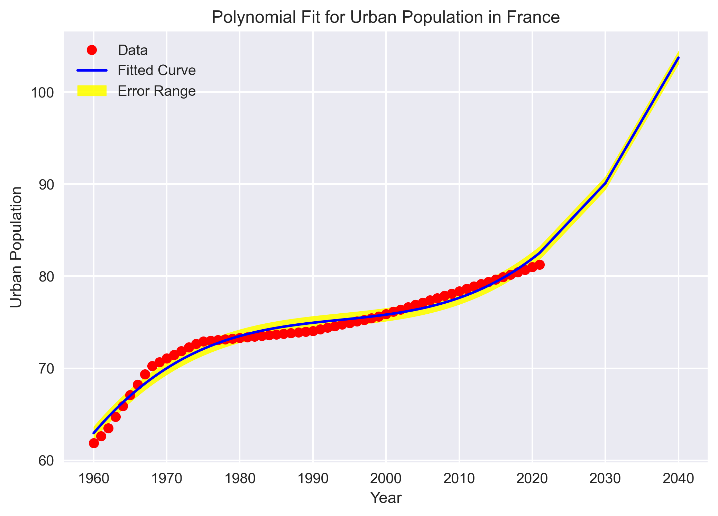

In 2010, France's urban population was 78.37%, reflecting its history of industrialization and economic development. By 2020, this increased to 80.98%, driven by migration to urban areas for better opportunities. The urban population is projected to reach 90.10% by 2030 and 100% by 2040, indicating almost complete urbanization. This steady growth highlights the need for sustainable urban planning, improved public services, and infrastructure development. Policymakers must address housing affordability, public transportation, and environmental sustainability to balance urban growth with maintaining quality of life and environmental standards.

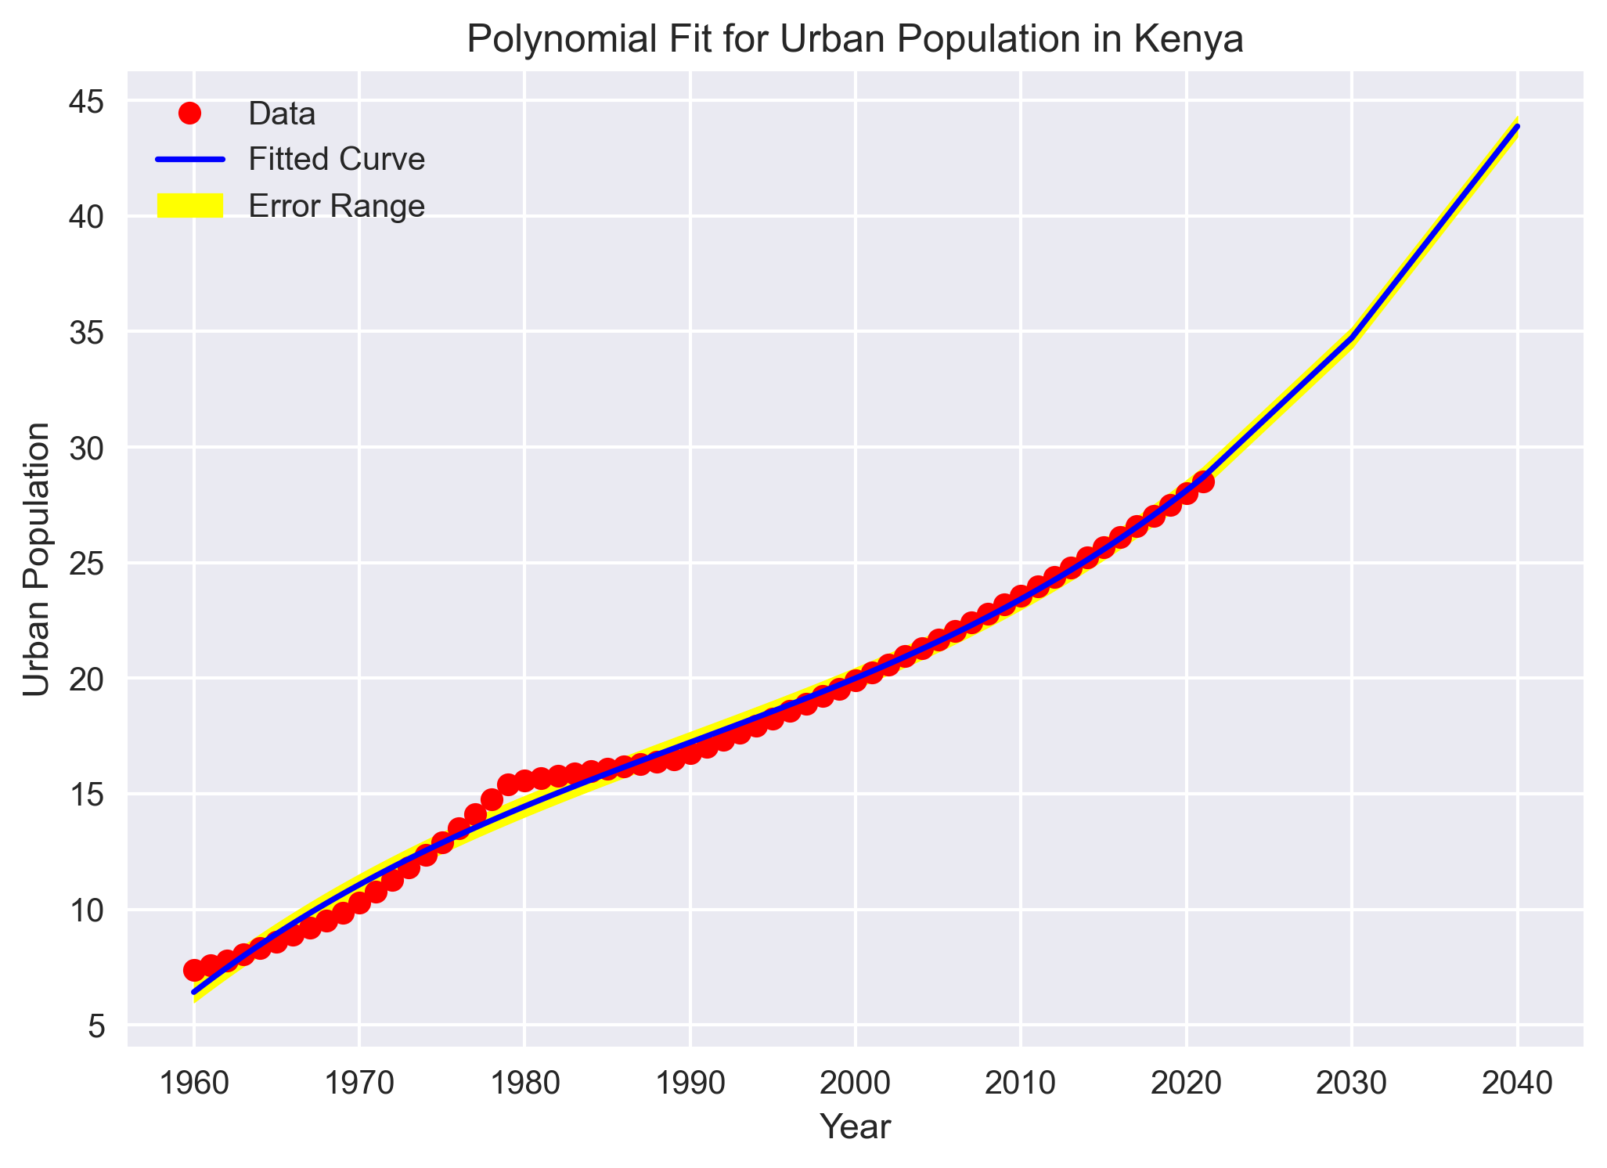

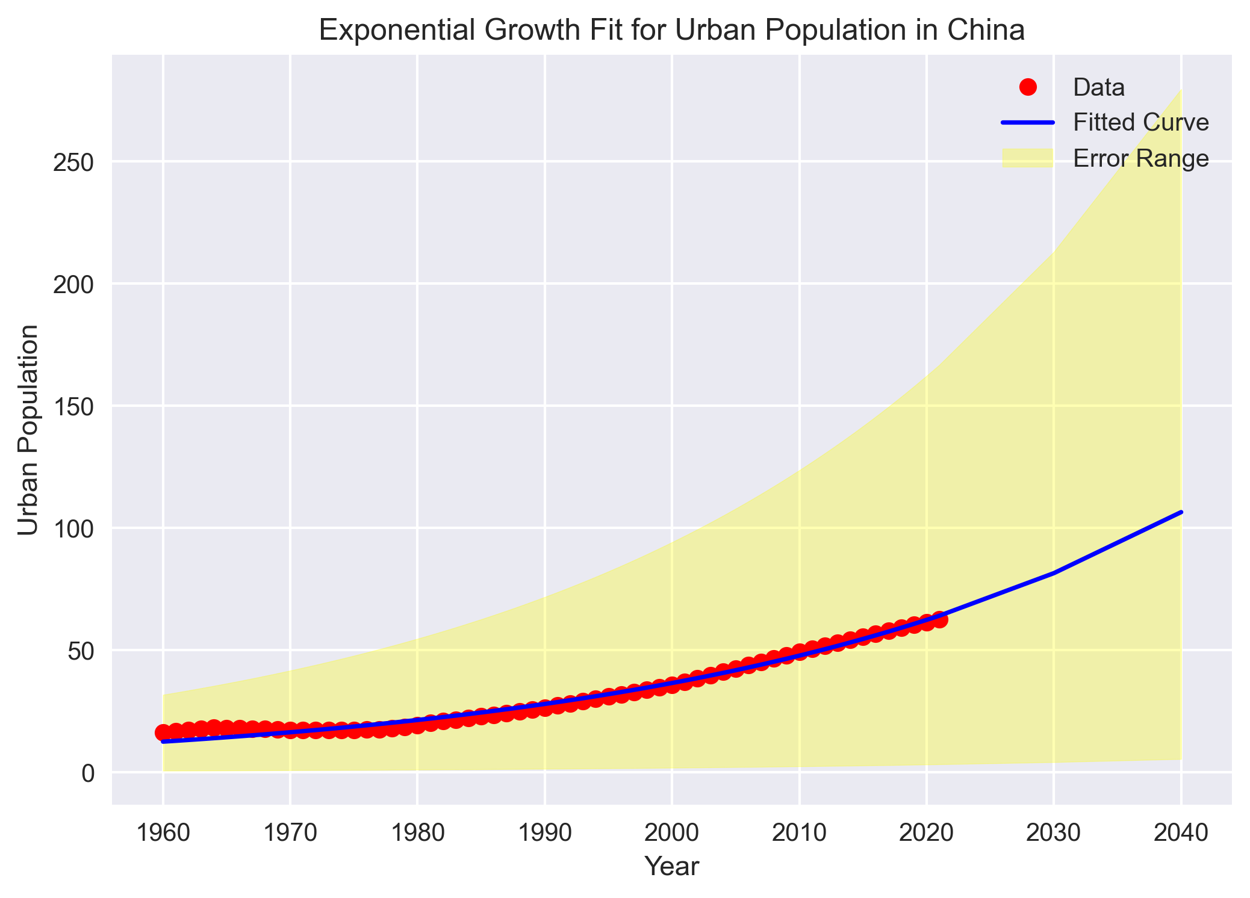China's urbanization has been rapid, rising from 49.23% in 2010 to 61.43% by 2020 due to economic reforms and industrialization. By 2030, the urban population is projected to reach 81.51%, with a dramatic increase to 106.4% by 2040, likely including floating populations. This rapid growth presents both opportunities and challenges, requiring policymakers to manage overcrowding, pollution, and resource depletion. Sustainable development, improved living standards, and equitable service access are crucial. The government must address environmental impacts and focus on creating livable, resilient cities.

In 2010, Kenya's urban population was 23.57%, rising to 27.99% by 2020 due to rural-to-urban migration. Projections show it will reach 34.72% by 2030 and 40% by 2040, indicating a gradual urban shift. This growth offers a chance for sustainable urban development, requiring enhanced infrastructure, housing, healthcare, and education. Policymakers must also tackle informal settlements and urban poverty to ensure balanced development

**Comparative Analysis**  
Urbanization Rates and Patterns:

* France shows a steady and consistent increase in urban population, indicative of a mature urbanization process.
* China exhibits rapid and large-scale urbanization, reflecting its economic policies and industrial growth.
* Kenya demonstrates a more gradual urbanization trend, with steady growth over the decades.

#### Policy Implications:

Understanding these varied urbanization patterns is crucial for developing targeted strategies. France may focus on sustainability and quality of life in its urban areas, China on managing the challenges of rapid urbanization, and Kenya on ensuring equitable access to urban opportunities and resources. Each country needs to tailor its urban planning and development policies to address its unique challenges and leverage its strengths for sustainable growth. By examining these trends, policymakers can develop informed strategies to manage urban growth effectively, ensuring sustainable development and improved quality of life for urban populations across different economic and regional contexts.

**Conclusion**

The study compares urbanization patterns in France, China, and Kenya, highlighting their unique growth trajectories. France's steady urbanization requires sustainable planning and improved services to maintain quality of life. China's rapid growth, driven by economic reforms, presents challenges like overcrowding and pollution, necessitating sustainable development and equitable service access. Kenya's gradual urbanization calls for enhanced infrastructure, housing, healthcare, and education to ensure inclusive development.